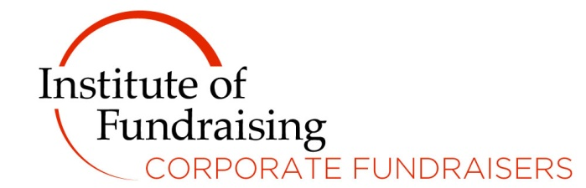

Bursary place for the Remarkable Partnerships’ Strategic Corporate Partnerships Masterclass 7-9 March 2018

The masterclass that enables you to step up your game and secure major long-term corporate partnerships.

We are excited to announce the launch of our bursary giving you the opportunity to attend the three day Remarkable Partnerships’ Strategic Corporate Partnerships Masterclass 7-9 March 2018.
For more information about the Strategic Corporate Partnerships Masterclass 2018, go to http://remarkablepartnerships.com/event/strategic-corporate-partnerships-masterclass/
To apply, please fill out the application form below and don't forget to share with your line manager to show they are backing you for this bursary - including any time out of the office it might incur etc.

Criteria

To apply for this bursary place you must:

- Applications are open to those working for UK registered charities.
- Be in a role at a charity where at least 50% of your job is corporate fundraising.
- Be fully committed to improving your fundraising skills.
The deadline to apply is 2 February 2018 5pm and we will advise entrants shortly thereafter.

What you will learn:

- How to move your organisation’s partnership focus from tactical to strategic.
- Our latest thinking on how to engage companies on their social purpose.
- How to think more creatively about value in a changing world.
- How inspirational and powerful partnerships are based on innovative ideas – and how to tell the good ideas from the bad.
- How to get your proposal read, by the decision makers.
- How to deliver an outstanding pitch.
- How to inspire your colleagues, create buy-in and develop a partnership culture.
- How to deliver an exceptional experience for companies that ensures long term partnerships.
- How to know what is a waste of your time.

APPLICATION FORM
Applicants must fill in the application form and submit their applications via email only. Applications must be submitted via email to corporatesig@gmail.com

SECTION A

Full name:

Job title:

Employer:

Charity Registration Number:

Correspondence Address:

Contact number(s):

E-mail address:

Number of Years in Fundraising:

SECTION B

Please use this space to write a clear and short letter of support for your application for the Bursary to attend the Strategic Corporate Partnerships Masterclass 2018

How will attending the Strategic Corporate Partnerships Masterclass impact your job and career and make the most out of the opportunity? (Maximum 250 words)

Line Manager’s Endorsement

Name:

Position:

Telephone Number:

Email:

Please describe why you believe the applicant would take advantage of this opportunity and why it would help your organisation deliver its fundraising strategy. (Please write not more than 200 words)

